Requirement Description
Project | Online Shopping
Requirement
Number
Title | Online Shopping
Type | New Feature
Primary Actor | Customer
Requirement Description | Customer needs to install require shopping app in their gadgets and need to register and then login into their page .customer need to select require items or clothes or groceries according to their requirement .customer need to add the selected items to their cart and proceed to purchase all those items by clicking on payment options .customer can do payment either by cash on delivery mode or through debit card or through payment apps like Phonepe , Gpay, paytm etc After completion of payment process customer will get a message or notification to mail as his/her order has been placed successfully and will get delivery date .He/she will also get tracking link of the order. He/she can track the order till item reaches his home.
Value to Primary Actor | Customer can reduce his/her time being wasted through online shopping . Both energy and time can be saved .Even business people gets benifited through this online shopping

User Interface Changes

Interaction Description
SNO | User does | What system does
1 | Whenever customer confirms the order by payment mode he or she will get order number given by the app | System provides order number based on item, customer address and billing
2 | Whenever order has been placed successfully he/she will get tracking link | System provides tracking link in order to track status of the order placed
3 | During the process of payment system provides OTP to the customer mobile in order to authenticate the customer | System provides OTP in order to check the customer details are real or fake
4 | Whenever customer selects some goods and placed in cart and not proceed further then he/she will get notification either to remove those items or proceed further to select another items | Software is designed in such a way that it will remind customer likes and to buy items/goods and it also provides similar kind of items

Screen Shot For Reference


Online Shopping by sitting at home itself

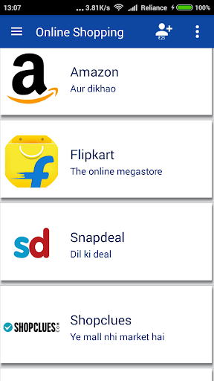

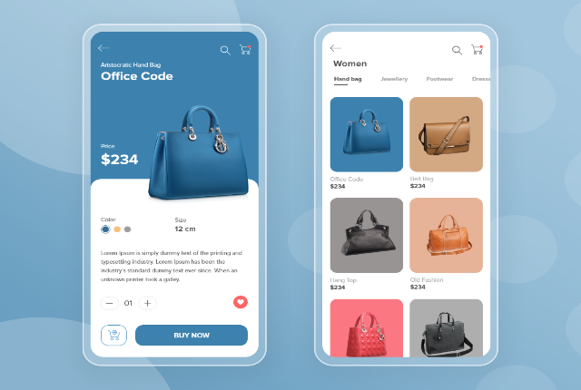
If customer selects one item application shows similar kind of items by default

- Rules and Validations
- Customer need to provide correct address in order to avoid disturbance from courier person
- Customer need to select trusted shopping site in order to protect them from Fraud sites

